Name: Abdul Rahim Dawra

ID: 24K-0633

Section: BCS-3A

Course Instructor: Mr. Abdullah Yaqoob

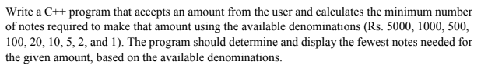

TASK # 1 by Abdul Rahim Dawra – 24K-0633

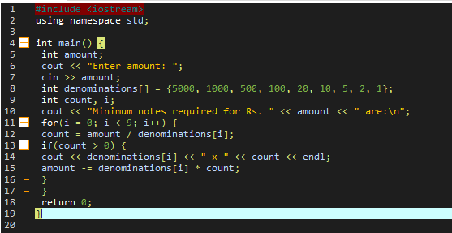

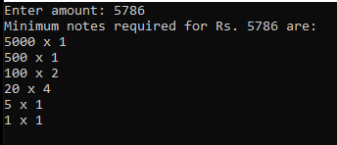

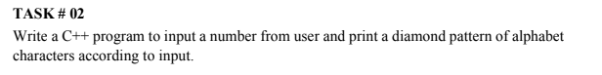

TASK # 2 by Abdul Rahim Dawra – 24K-0633

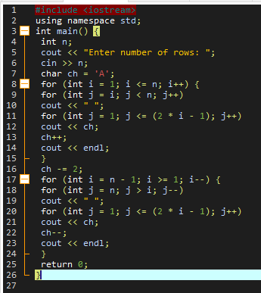

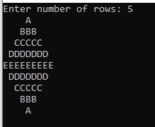

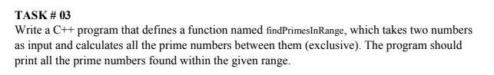

TASK # 3 by Abdul Rahim Dawra – 24K-0633

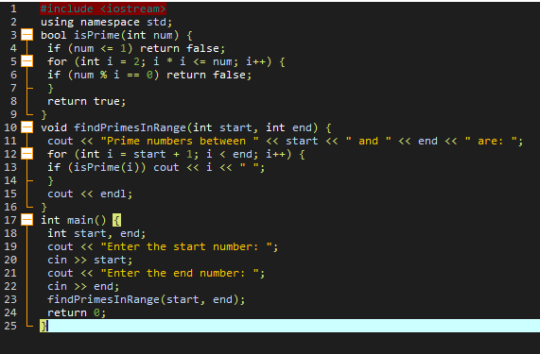

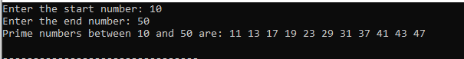

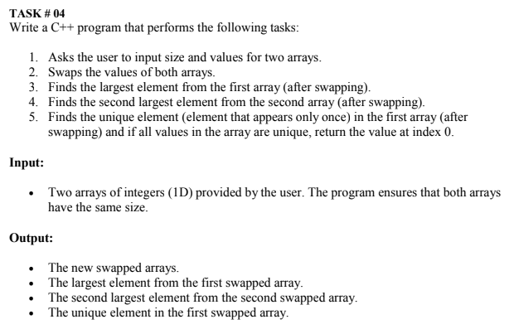

TASK # 4 by Abdul Rahim Dawra – 24K-0633

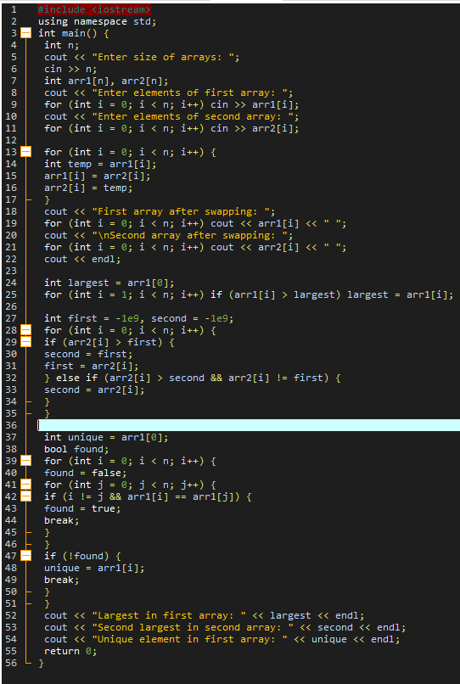

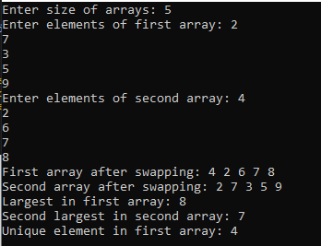

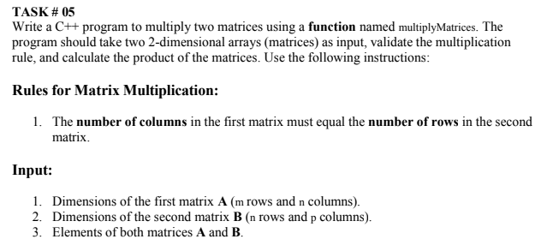

TASK # 5 by Abdul Rahim Dawra – 24K-0633

